**FRESH TEACHER'S E-LIBRARY**

**BEGINNING OF TERM III EXAMINATION 2023**

**BABY CLASS: (3 – 4 YEARS)**

**LEARNING AREA 5: LANGUAGE DEVELOPMENT II**

**My name is: ……………………………………………………………….**

**My School is: …………………………………….………………………..**

**I am in: ………………………………..…………………………….…………………..**

1. **Colour the friends of sound ‘e’.**

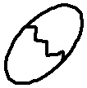



1. **Trace and read the sound.**
2. **Match the sound to the friends.**





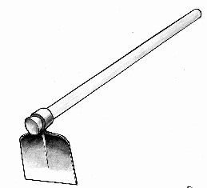

D:\BECKY\images\kibuuka pic\ball 3.jpg

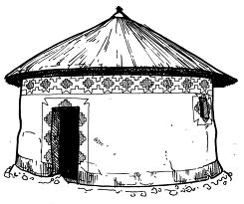

1. **Match the same pictures.**

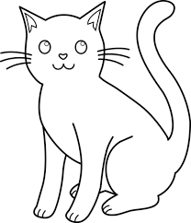

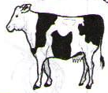

**D:\BECKY\images\DISAN PICS\pics PART 2\pics\burning candle.bmp**







**D:\BECKY\images\DISAN PICS\pics PART 2\pics\burning candle.bmp**



1. **Read and copy sound ‘h’.**

|  |  |  |  |
| --- | --- | --- | --- |
| **h** | **h** | **h** | **h** |
|  |  |  |  |
|  |  |  |  |
|  |  |  |  |
|  |  |  |  |
|  |  |  |  |

**End**